

DEPARTMENT OF INFORMATION TECHNOLOGY

GAUHATI UNIVERSITY

GNB Nagar, Guwahati-14

COMPLAINT MANAGEMENT SYSTEM

for

APDCL (Assam Power Distribution Company Limited), Guwahati, Assam

A Summer Internship Report submitted in partial fulfilment of the requirement for the degree of Bachelor of Technology in Information Technology, Gauhati University (GU)

UNDER THE GUIDANCE

OF

Sujan Sen, AM(IT)

IT Sector, APDCL

Submitted By,

Yashin Khan (Roll no.: 210101020)

Ankita Choudhury (Roll No.: 210102028)

Darshan Nath (Roll No.: 210101035)

Kushanku Hazarika (Roll No.: 210104006)

Tanmoy Deka (Roll No.: 210102006)

BTech, 4th Semester,

IT Dept., GU

DECLARATION

We, Ankita Choudhury, Darshan Nath, Kushanku Hazarika, Yashin Khan and Tanmoy Deka, B.Tech. students of the department of Information Technology, Gauhati University, hereby declares that we have compiled this report reflecting all our works during the Summer Internship in APDCL (Assam Power Distribution Company Limited) as partial fulfilment of the requirements of the degree of Bachelor of Technology in Information Technology, Gauhati University.

ANKITA CHOUDHURY

DARSHAN NATH

KUSHANKU HAZARIKA

YASHIN KHAN

TANMOY DEKA

B.Tech., 4th Semester, IT

GAUHATI UNIVERSITY

Date:

Place: Guwahati, Assam

CERTIFICATE OF APPROVAL

This is to certify that the work contained in the Summer Internship Report entitled “APDCL Complaint Management System” by Ankita Choudhury (210102028), Darshan Nath (210101035), Kushanku Hazarika (210104006), Tanmoy Deka (210102006) and Yashin Khan (210101020) of B.Tech. 4th Semester, Dept. of Information Technology, Gauhati University, Guwahati-14, Assam, for the partial fulfilment of the degree of Bachelor of Technology has been carried out under my supervision and that work has not been submitted elsewhere for a degree.

Date:

Place: Guwahati, Assam Signature

ACKNOWLEDGEMENT

We would like to express our sincere gratitude to all those who supported us throughout the work of our Summer Internship. We are thankful for their aspiring guidance, valuable time, invaluably constructive and friendly advice during the internship.

We convey our special thanks to Sujan Sen ,AM(IT) for their constant support and guidance at IT Cell, Assam Power Distribution Company Limited (APDCL), Bijulee Bhawan, Guwahati during our Summer Internship.

Finally, we would like to thank our parents, who have been great to us throughout our whole life, and without whom none of this would have been possible.

Thanking all of you.

Sincerely,

ANKITA CHOUDHURY

DARSHAN NATH

KUSHANKU HAZARIKA

YASHIN KHAN

TANMOY DEKA

B.Tech., 4th Semester, IT

GAUHATI UNIVERSITY,

Guwahati

Table of Contents

1.Abstract……………………………………………………………………………………..7

2.Introduction………………………………………….......................................8

3.Inspiration………………………………………………………………………………….10

4.Working……………………………………………………………………………………..11

5.Project Management…………………………………………………………………13

5.1. Overview of project stages……………………………………………….13

6.Challenges and solutions…………………….........................................16

7.Purpose………………………………………................................................18

8.Results………………………………………………………………………………………19

9.Conclusion………………………………………………………………………………..25

List of Figures/Images

1.Flowchart…………………………………………………15

2.ER Diagram………………………………………………16

3.Structure………………………………………………….17

4.Home page………………………………………………..19

5.User login……………………………………………....…19

6.User profile……………………………………………….20

7.Complaint Registration page…………………………..…20

8.User Complaint History……………………………….….21

9.User complaint details………………………………….…21

10.Admin login…………………………………………..…22

11.Admin Dashdoard……………………………………….22

12.Admin complaint details………………………………...23

13.Categorisation panel…………………………………….23

14.Complaint management panel…………………………..24

15.Export To Excel Panel…………………………………..24

ABSTRACT

The web-based Complaint Management System for APDCL (Assam Power Distribution Company Limited) is a practical software solution developed to address the needs of APDCL's consumers. The system focuses on providing a user-friendly and efficient platform for consumers to report complaints related to power supply, billing, metering, and other relevant issues. By streamlining the complaint management process, the system aims to enhance consumer satisfaction and facilitate timely resolution of complaints.

The APDCL Complaint Management System features a user-friendly web interface designed to simplify the complaint submission process for consumers. It enables them to conveniently submit complaints online, eliminating the need for physical visits or phone calls. The system contains the essential consumer information, including contact details and location, along with specific details of the complaint if necessary. These details are securely stored in a centralized database for further processing.

Upon complaint submission, the system assigns a unique complaint ID to facilitate efficient tracking and monitoring throughout the resolution process. The system categorizes and prioritizes complaints based on their severity and urgency, allowing APDCL to allocate appropriate resources and prioritize timely resolution. Consumers can track the status of their complaints in real-time through the system, ensuring transparency and keeping them informed of the progress.

The system incorporates analytics capabilities to generate insightful reports and performance metrics. These reports help APDCL identify recurring issues, analyze trends, and make data-driven decisions to improve complaint management processes. By leveraging these insights, APDCL can enhance operational efficiency, identify areas for improvement, and deliver a better consumer experience.

In conclusion, the web-based APDCL Complaint Management System for APDCL, provides an effective solution to address the needs of APDCL's consumers in Assam. By leveraging technology, analytics, and user friendly, the system enhances transparency, consumer satisfaction, and the timely resolution of complaints. This offers valuable experience in developing a practical software solution tailored to the specific requirements of APDCL's consumer complaint management.

INTRODUCTION

In today's fast-paced world, reliable and efficient electricity services are vital for both residential and commercial consumers. However, issues and complaints can occasionally arise, affecting the quality of service provided by power distribution companies. To address this challenge, a comprehensive web-based Complaint Management System for APDCL (Assam Power Distribution Company Limited), Assam is developed. This report provides an overview of the system, its objectives and the benefits along with some other beneficial points it offers to APDCL consumers.

APDCL is a prominent power distribution company in Assam, India, responsible for supplying electricity to millions of consumers. Recognizing the significance of consumer satisfaction and the need for efficient complaint resolution, a Complaint Management System for APDCL has been developed. This system aims to streamline the complaint handling process, ensuring timely and effective resolutions to consumer issues.

The primary objectives of the APDCL Complaint Management System are as follows:

a***. Efficient Complaint Handling***: The system aims to provide a structured and streamlined approach to handle consumer complaints. It seeks to ensure that complaints are promptly registered, tracked, and resolved with minimal delays.

b***. Transparency and Accountability***: The Complaint Management System promotes transparency by providing consumers with real-time access to the status of their complaints. It also holds APDCL accountable for resolving complaints within defined timelines.

c***. Enhanced Consumer Satisfaction***: By expediting complaint resolution and providing regular updates, the system strives to enhance consumer satisfaction. It aims to minimize inconvenience caused by service issues.

d***. Continuous Improvement***: By allowing the consumers to describe the issue faced by them in an elaborative way and provide suggestions for further issues enable APDCL to identify areas for improvement. By actively incorporating consumer suggestions, APDCL can refine its services and address recurring issues more effectively.

The APDCL Complaint Management System offers the following key features and functionalities:

a***. User-friendly Interface***: The system provides a user-friendly website where consumers can easily register complaints and navigate through the complaint resolution process.

b***. Ticketing***: Each Complaint is assigned a unique token number or reference number which helps in tracking and managing the complaint throughout its lifecycle.

c***. Real-time Tracking***: Consumers have access to a personalized dashboard that allows them to track the progress of their complaints in real-time. They can monitor the status, view any updates through our website.

The APDCL Complaint Management System serves as an invaluable tool in improving consumer satisfaction and enhancing efficiency in complaint resolution. By embracing technology and providing a transparent and user-friendly platform, APDCL is committed to addressing consumer concerns promptly and effectively. Through this website, APDCL aims to build a stronger relationship with its consumers, based on trust, responsiveness, and customer-centricity.

As APDCL continues to prioritize consumer needs and works towards continual improvement, the Complaint Management System stands as a testament to its commitment to delivering reliable electricity services and ensuring consumer satisfaction in Assam.

INSPIRATION

The inspiration behind building a complaint management system website for users can stem from several factors. Here are a few potential motivations:

***Enhancing Customer Satisfaction:*** A complaint management system aims to improve customer satisfaction by providing a platform for users to express their concerns or dissatisfaction. The inspiration may arise from a desire to create a seamless and efficient process for users to submit their complaints, allowing businesses to address and resolve issues promptly.

***Improving Communication and Transparency:*** A complaint management system website can serve as a centralized hub for users to communicate their grievances directly to the relevant departments or individuals within an organization. This transparency helps build trust and demonstrates that the company values feedback from its customers.

***Streamlining Processes:*** The inspiration may come from a need to streamline the complaint handling process within an organization. By implementing a website dedicated to managing complaints, businesses can automate various stages of the process, such as ticket creation, assignment, tracking, and resolution. This automation can lead to improved efficiency, reduced response times, and better overall complaint resolution.

***Data Analysis and Insights:*** Building a complaint management system website allows businesses to gather valuable data and insights regarding the nature and frequency of complaints. Analysing this data can uncover patterns, identify recurring issues, and help organizations make data-driven decisions to address root causes and prevent future complaints. The inspiration may come from a desire to harness this valuable information for continuous improvement.

***Competitor Differentiation:*** In a competitive market, offering a user-friendly and efficient complaint management system can differentiate a business from its competitors. The inspiration behind building such a system may arise from a strategic perspective, where companies aim to provide an outstanding customer experience, even when handling complaints, to stand out in the marketplace.

***Compliance and Regulatory Requirements:*** In certain industries, businesses may be obligated to implement complaint management systems to comply with specific regulations or industry standards.

HOW WE BUILT IT

To build a complaint management system website using HTML, CSS, JavaScript, and PHP, we would typically follow a multi-step process. Here's an overview of each step and the tasks involved:

***Designing the User Interface:***

Create the basic structure of the website using HTML, including header, navigation, content sections, and footer.

Apply CSS to style the website elements, ensuring a visually appealing and user-friendly interface.

Design the complaint submission form using HTML form elements and CSS styling.

***Implementing Client-Side Functionality with JavaScript:***

Validate user inputs in the complaint submission form using JavaScript to ensure the required fields are filled, proper formats are used, etc.

Handle form submission events, such as capturing form data and preventing default form submission behaviour.

Implement client-side interactions, such as displaying success messages or error notifications.

***Setting up the Server-Side Environment:***

Install and configure a local web server environment (e.g., Apache, PHP, MySQL) on web development machine.

Create a MySQL database to store complaint-related information, such as user details, complaint description, status, etc.

***Handling Complaint Submission and Storage with PHP:***

Write PHP code to handle form submissions, retrieve data from the submitted form, and sanitize and validate the inputs. Establish a connection to the MySQL database using PHP and handle the insertion of complaint data into the appropriate database tables.

***Implementing Complaint Tracking and Management:***

Create PHP scripts to retrieve and display complaint information from the database, such as listing all complaints, filtering by status or category, etc.

Develop PHP functions to update the status of complaints, assign complaints to specific departments or personnel, and track the resolution progress.

***Incorporating User Authentication and Access Control:***

Implement user authentication functionality, allowing users to create accounts and log in to access the complaint management system.

Designate user roles and permissions to control access to different parts of the system, such as administrators, support staff, and regular users.

***Adding Additional Features:***

Enhance the system with additional functionalities, such as email notifications to users and administrators when a complaint is submitted or resolved, generating reports and analytics, etc.

Implement search and filtering capabilities to allow users to easily find specific complaints based on different criteria.

Throughout the development process, we would need to write the necessary code in HTML, CSS, JavaScript, and PHP to accomplish the tasks mentioned above. It's important to follow best practices for security, data validation, and code organization.

Please note that building a complete complaint management system website requires a comprehensive understanding of these technologies and potentially additional frameworks or libraries. It may be beneficial to consult relevant documentation and tutorials or seek assistance from experienced developers if needed.

PROJECT MANAGEMENT:

Evolutionary Prototyping was agreed upon as the method for the developing this website. Prototyping is an excellent method to ensure your project stakeholder is satisfied with your product. The users can be actively involved when using this method which is very important for a project involving website building. By using Evolutionary Prototyping specifically, the end product is a working model of your website and so this can give the developers a clear indication to show if they have met the user’s needs for the website. If the website fails to function as conceptualised by the user, this can provide timely feedback to the developers. This methodology requires the developers to check errors and deal with them as they develop the system with is the potential risk when undertaking a project doing this. Time management will have to be strictly enforced to ensure the team can produce the end product within the set deadline. The prototyping can be iterative and so if the stakeholder is not happy with the test prototype, it can be refined to produce the final product.

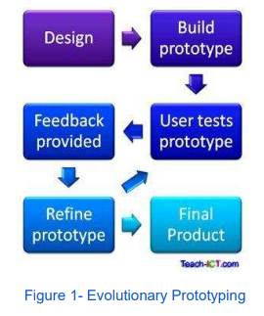

Overview of Project Stages

User Analysis

User analysis was the primary focus for the team: the target audience and market were clearly identified. Based on this information the team brainstormed to gather ideas of how we could meet these user requirements. Roles, responsibilities and associated schedules were put in place to guide the team and to initialize time management. Policy and security issues were addressed at the start so that guidelines would be followed through the prototyping. Quality assurance and testing took place through the prototyping to check for errors and defects. The stakeholder was consistently involved in the design and implementation, as was communicated with regularly to review risks.

Conceptual Design

The team collated information from a collaborative brainstorming and conceptualised a design using paper prototypes. This low fidelity prototyping allows the team to be creative and allow a free flow of ideas. Interface Design by using website wire framing helped to concrete our conceptual design of the website. The Interface design screens were presented to the stakeholder and any partially complete requirements were identified at this stage.

Implementation

The team refined their design based on changes to initial requirements. At the first stage of implementation when system design is formed the quality assurer will create tests and will be responsible for debugging the system throughout. As this project was undertaken and guided by an evolutionary prototyping methodology. Testing will take place throughout and not at the end of the development.

Testing

Testing is an essential when creating a responsive website. Testing took place throughout the project as the prototype was developed. The website was accessed in different browsers and updated accordingly. Multiple Device Resolutions were tested testing using the online quirk tools website. This allowed us to verify the website in resolutions for multiple types of phones, tablets and monitor screens to verify content images and banner images responded correctly with the adjusted screen view. In the case failure of an image loading, all images have an alt tag so if the image does not load the user knows what the image was supposed to represent. We also verify the resolution of content was maintained when undertaking the device platform testing. The code for the main components of the website, like the navigation bar are repeated on every page and we needed to test to make sure no pages were missed when a change was required. We develop a plan for testing all of the website content on each page to make sure it was consistent and had not been broken by any updates made to the code.

Refining

After the prototype of the website was successfully created, we ensured that it was fully functional with no errors or defects, and then it was presented to the company. The website was intensely tested to ensure complete functionality before producing the final version of the fully functional prototype.

Completion

The final product fully met the requirements set out by the company and the user experience was highly rated.

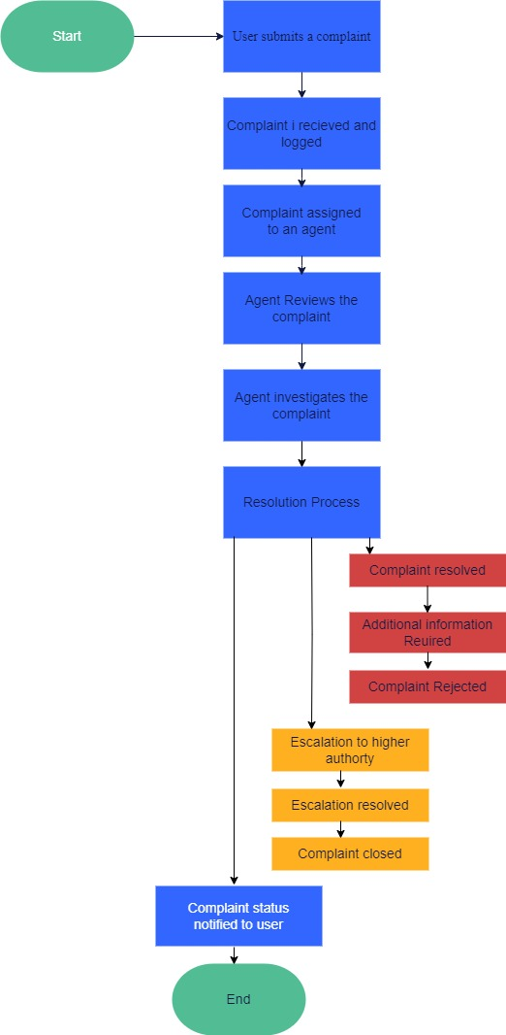

Fig: Flowchart

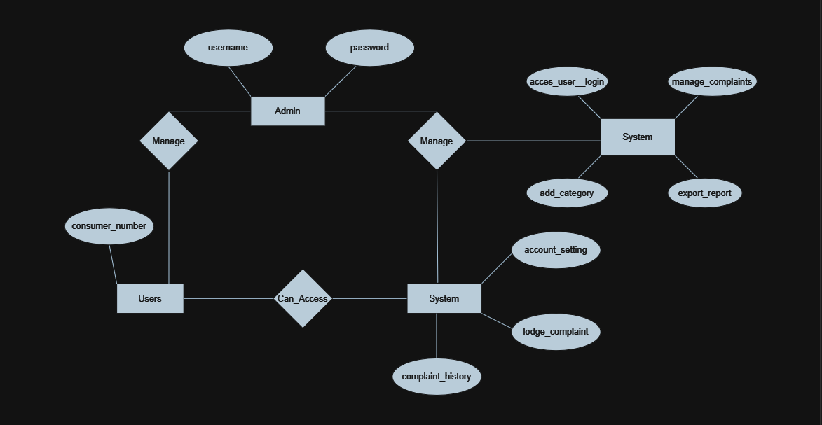

Fig: Er Diagram

**CHALLENGES FACED AND HOW THEY WERE RESOLVED:**

While building a complaint management system website, we may encounter various challenges. Here are some common ones that developers often face during the development process:

* ***Requirements Gathering:*** One of the initial challenges is gathering clear and comprehensive requirements from stakeholders. Ensuring a thorough understanding of the desired features, workflows, and user expectations is crucial for successful development.
* ***User Interface Design:*** Designing an intuitive and user-friendly interface can be challenging. Balancing aesthetics with usability, considering different screen sizes and devices, and meeting accessibility standards may require iterative design and feedback from users.
* ***Data Validation and Security:*** Implementing robust data validation and security measures can be complex. Ensuring input data is properly validated, handling potential security vulnerabilities, and protecting sensitive user information require a deep understanding of security best practices.
* ***Design and Performance:*** Designing an efficient database structure and optimizing database queries for performance can be challenging. Balancing data normalization, establishing relationships between tables, and handling large volumes of data may require careful planning and tuning.
* ***Workflow and Business Logic:*** Implementing the complaint handling workflow and business logic can be intricate. Assigning complaints to appropriate departments or individuals, tracking progress, and ensuring smooth collaboration between stakeholders can present challenges.
* ***Error Handling and Logging:*** Handling and managing errors effectively is important for a reliable system. Implementing error handling mechanisms, logging errors for debugging purposes, and providing meaningful error messages to users can be challenging.
* ***Testing and Quality Assurance:*** Ensuring the website's functionality, usability, and security requires thorough testing. Developing comprehensive test cases, performing unit testing, integration testing, and user acceptance testing can be time-consuming but essential for a robust system.
* ***Scalability and Performance:*** Building a system that can handle increased user load and scale with growing complaint volumes is a challenge. Optimizing code, database queries, and server infrastructure to handle concurrent requests and maintain system performance is vital.
* ***User Adoption and Training:*** Introducing a new complaint management system to users and ensuring its successful adoption can be challenging. Providing proper user training, addressing user concerns, and encouraging user engagement with the system require effective change management strategies.

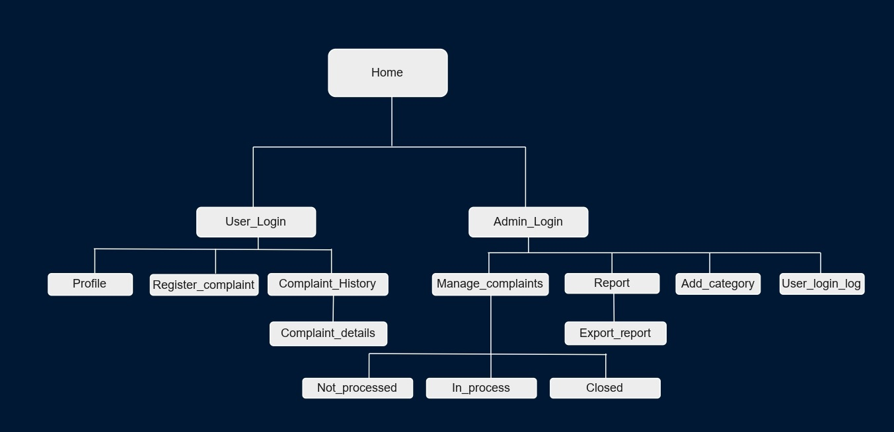

Fig: Structure

WHAT IT DOES

A complaint management system website is designed to facilitate the handling, tracking, and resolution of customer complaints. Here are some key functionalities typically provided by such a website:

***Complaint Submission:*** Users can submit their complaints through an online form or portal. The website collects essential information such as the user's contact details, description of the complaint, relevant attachments, and any supporting documentation.

***Tracking:*** Each complaint is assigned a unique ticket or reference number, which helps in tracking and managing the complaint throughout its lifecycle. Users can receive updates on the progress of their complaints and check the status of their tickets through the website.

***Categorization and Prioritization:*** The complaint management system allows for categorizing complaints based on their nature or specific departments involved. This categorization helps in prioritizing and assigning complaints to the appropriate personnel for resolution.

***Workflow Management:*** The website provides a workflow management system to streamline the complaint handling process. It ensures that complaints are routed to the relevant departments or individuals responsible for addressing specific issues. The system can automatically assign and escalate complaints based on predefined rules and criteria.

***Communication and Collaboration:*** The complaint management system website enables seamless communication between users and the company's customer support or complaint handling team. Users can exchange messages, provide additional information, and receive responses through the website, ensuring a centralized and efficient communication channel.

***Feedback and Customer Satisfaction Surveys:*** Some complaint management systems *include* features for collecting feedback and conducting customer satisfaction surveys. These mechanisms allow organizations to gather user feedback on the complaint handling process itself and measure customer satisfaction levels.

Results :

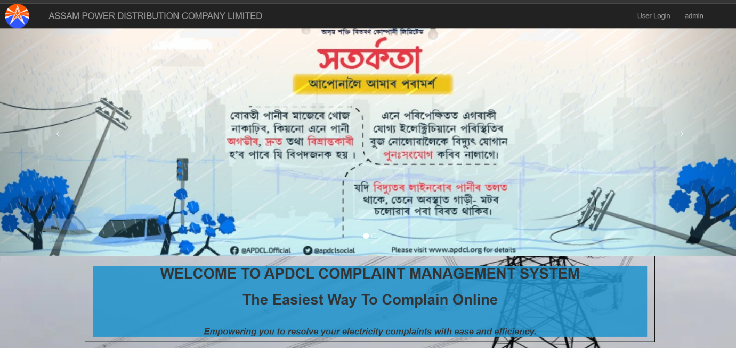

Fig: Home Page

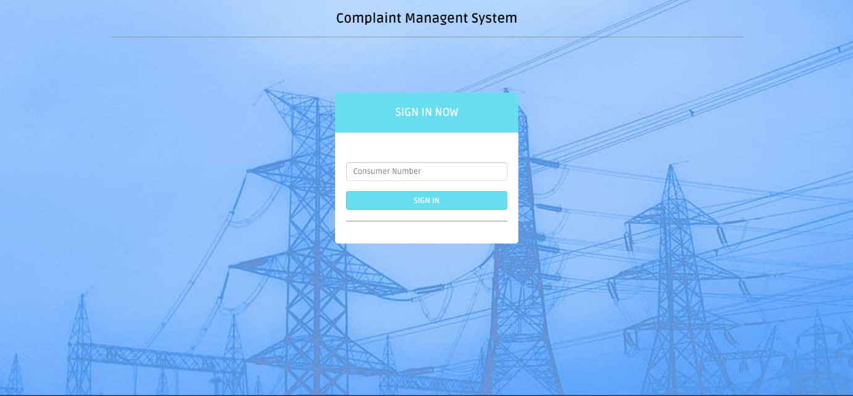

Fig: User Login

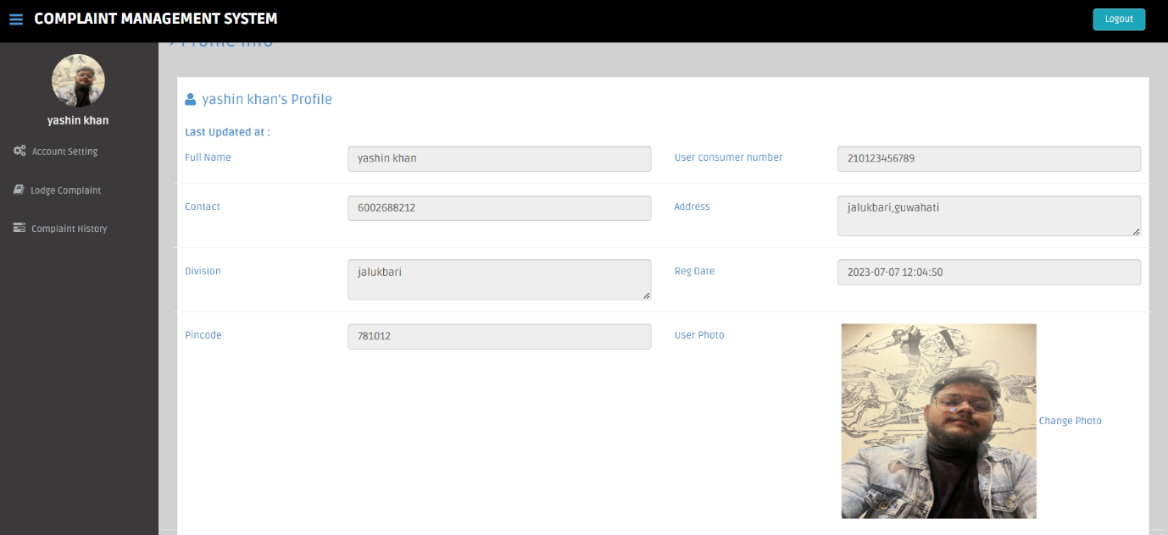

Fig: User Profile

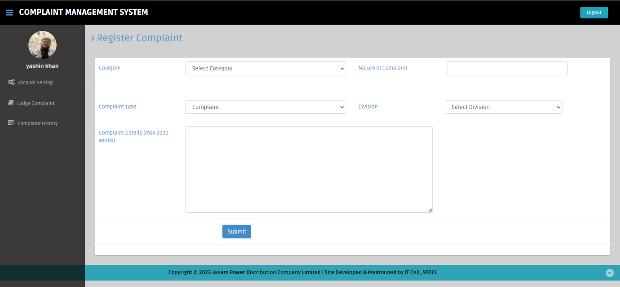

Fig: complaint registration page

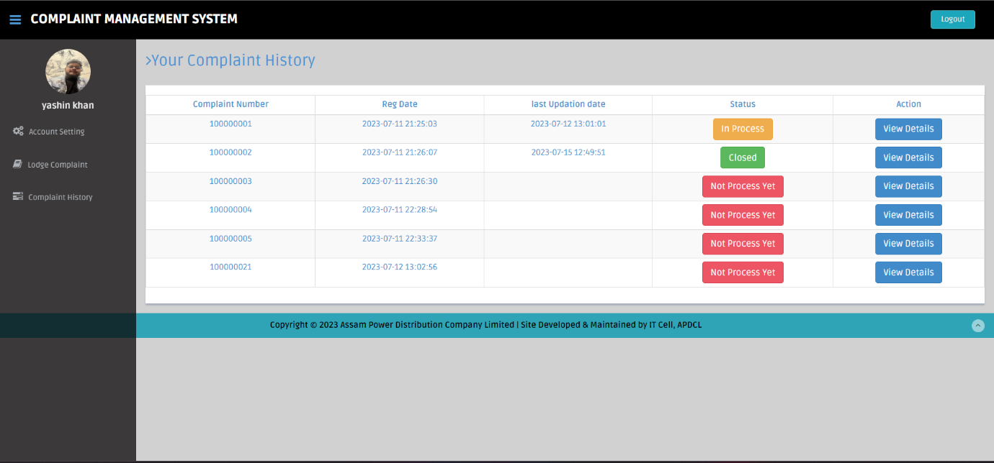

Fig: User complaint history

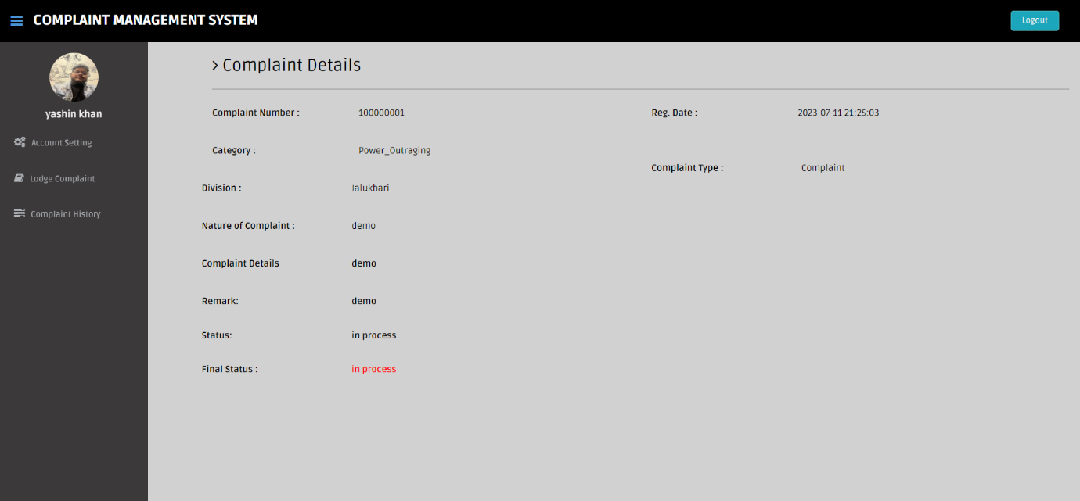

Fig: User complaint details

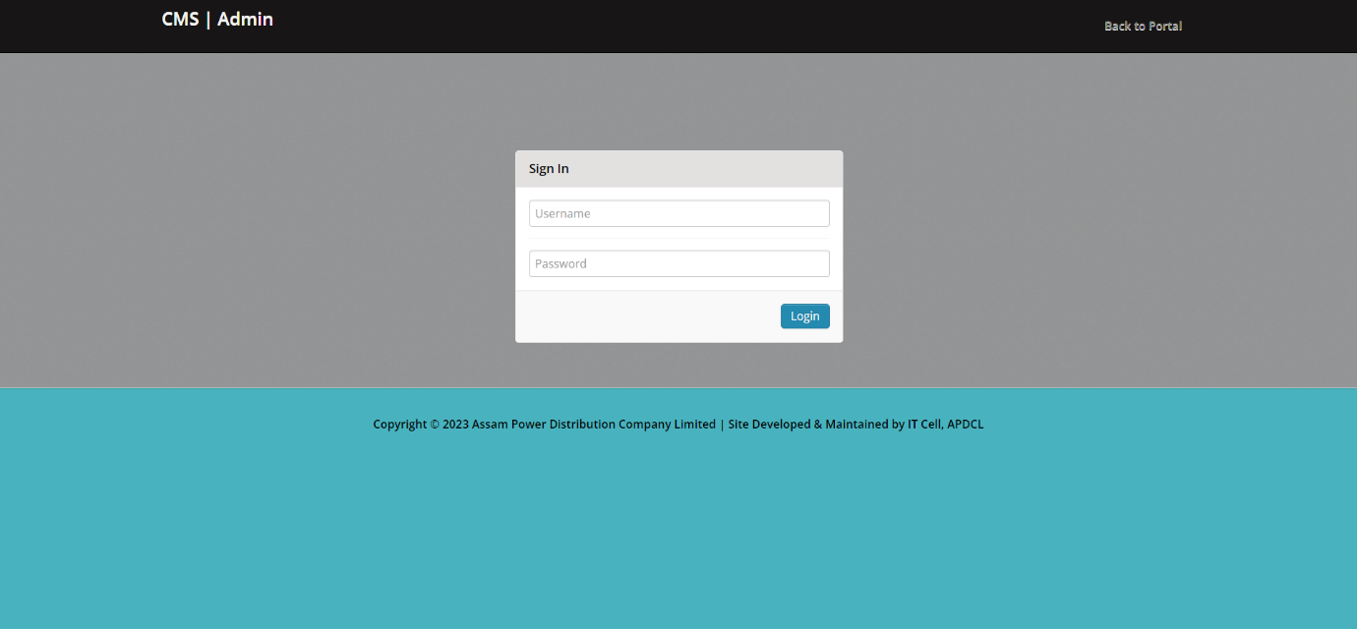

Fig: Admin Login

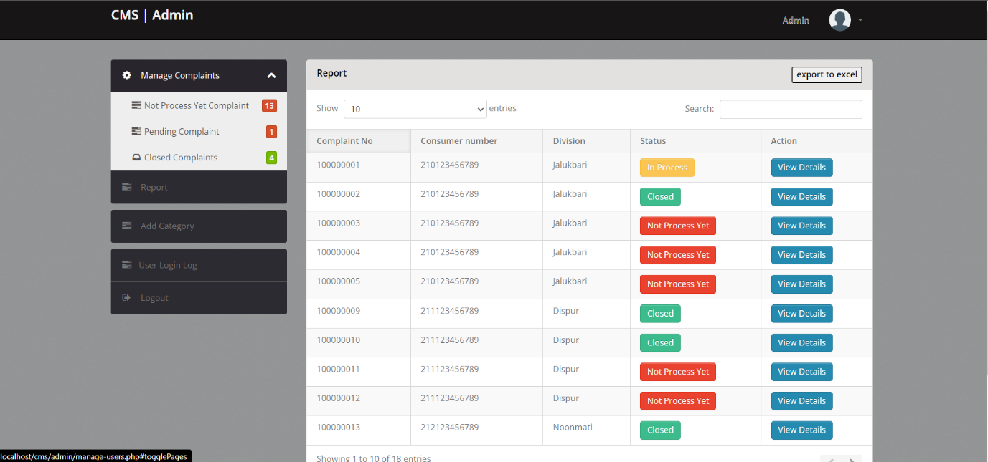

Fig: Admin Dashboard

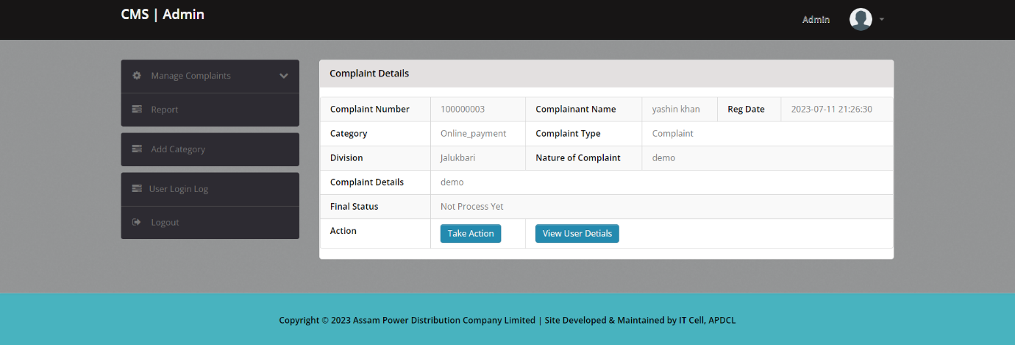

Fig: Complaint Details

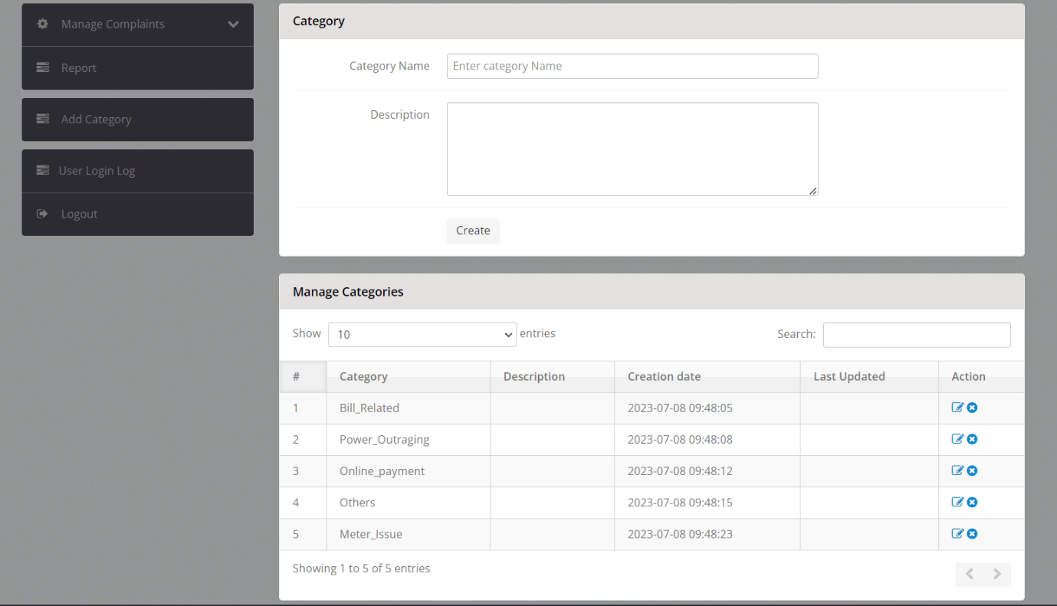

Fig: Categorisation panel

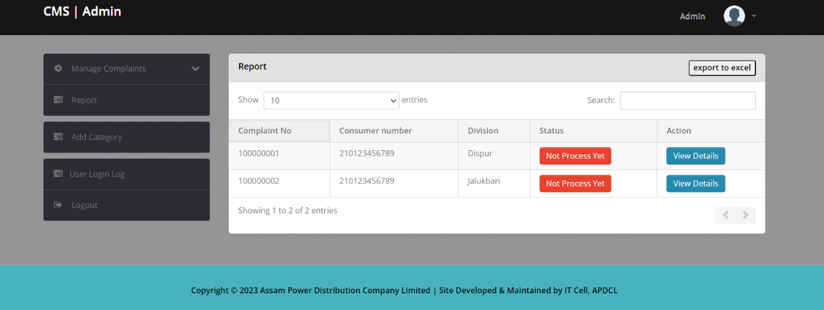

Fig: Complaint Management Panel

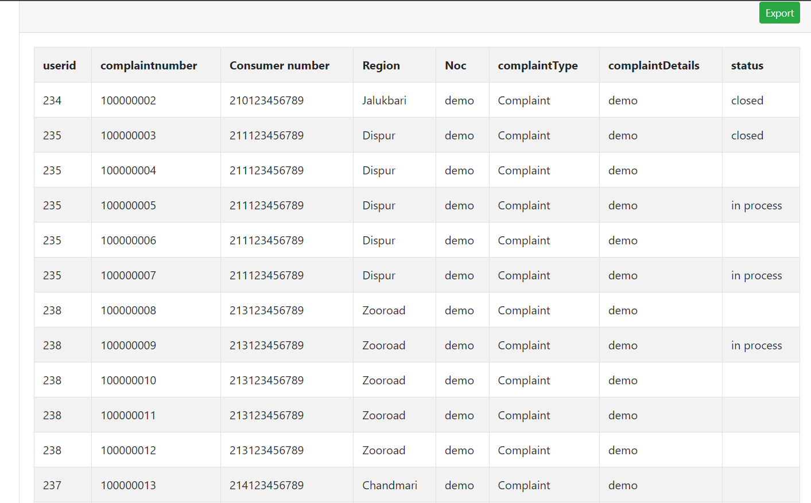

Fig: Export to Excel panel

Conclusion

The APDCL Complaint Management System represents a significant milestone in its commitment to ensuring consumer satisfaction and operational efficiency. By implementing this user-friendly platform for complaint management, it has revolutionized the way it handles consumer concerns.

Throughout this report, we have discussed the objectives and features of our Complaint Management System. The primary goal has been to streamline the complaint handling process, enhance transparency and accountability, elevate consumer satisfaction, and continually improve our services.

By providing a user-friendly interface, it has made it convenient for consumers to register their complaints online. This eliminates the need for physical visits to complaint centres and saves valuable time and effort. Real-time tracking allows consumers to monitor the progress of their complaints, giving them a sense of control and keeping them informed with just a click. Automated notifications provide updates on the status of their complaints, ensuring timely communication and engagement.

In conclusion, the web-based APDCL Complaint Management System is a powerful tool in our efforts to enhance consumer satisfaction and streamline operations. By embracing technology and providing a transparent and user-friendly platform, it aims to foster a stronger relationship with the valued consumers. It will remain committed to resolving complaints efficiently, minimizing inconveniences, and continually improving our services to deliver the highest level of consumer satisfaction.